**Cryptography Prescriptions 1.0.0.0 Release Notes**

**Application Release Information**

|  |  |
| --- | --- |
| **Product:** | **Cryptography Prescriptions** |
| **Release Number:** | 1.0.0.0 |
| **Release Date:** | 12/06/2017 |
| **Deliverable:** | There are two deliverables:   1. Web Service 🡪 interfacing six web methods 2. [Exe](https://vpstaging.finance360.org/mtacplus/login.aspx)cutable file (with all dependencies) |

**Introduction**

This document contains the release notes for Cryptography Prescriptions 1.0.0.0.

**Functionality**

* An Integrated Environment for a User-driven Automated Generation of Implementations of Cryptography Solutions specifically for the following scenario: Party 1 stores on and later retrieves hashed passwords from Party 2.

**Dependencies**

**Operating System:**

* Windows 7/8/10.

**Black-box testing:**

* Microsoft .NET Framework 4.0 – Install from the following location:
* <https://www.microsoft.com/en-us/download/details.aspx?id=17851&751be11f-ede8-5a0c-058c-2ee190a24fa6=True>

**Step 1 – Web Service: (both source and published web service contents have been uploaded)**

* Deploy the web service in virtual directory accessible over internet with .NET framework 4.0 installed. The path to access web service would be <http://SERVER_NAME/Secureme/SecureMe.asmx>. Replace SERVER_NAME with the actual server name.
* For testing purpose we may host web service by running in the Visual Studio Solution, configured to hear at 5114. On localhost the URL would be <http://localhost:5114/SecureMe.asmx>.

**Step 2 – Windows Application:**

* bin\x86\Debug \CryptographyPrescriptions.exe

**White-box testing:**

There are 2 solutions:

1. CryptographyPrescriptions 🡪 Windows Application
2. CryptoServices

* **­**For complete application structure - Microsoft Visual Studio 2015 any edition.
* For code review – Any C# compatible editor

**Application Configuration:**

* First step, use must deploy (listening on a given port) the CryptoServices as given in the step 1.
* **Exe Path:** bin\x86\Debug \CryptographyPrescriptions.exe
* User must copy the CryptographyPrescriptions.mdb as ..\\..\\..\\CryptographyPrescriptions.mdb with respect to CryptographyPrescriptions.exe.
* Default port is set as 5114. User may change the port then must provide the updated link on first tab *Service URL* (after running the exe file):

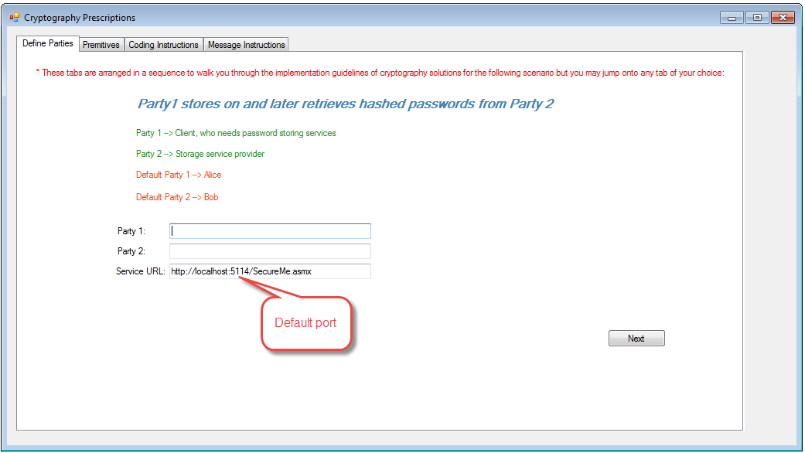

* If web service is running user must be able to see all web methods on browsing:

<http://localhost:5114/SecureMe.asmx>

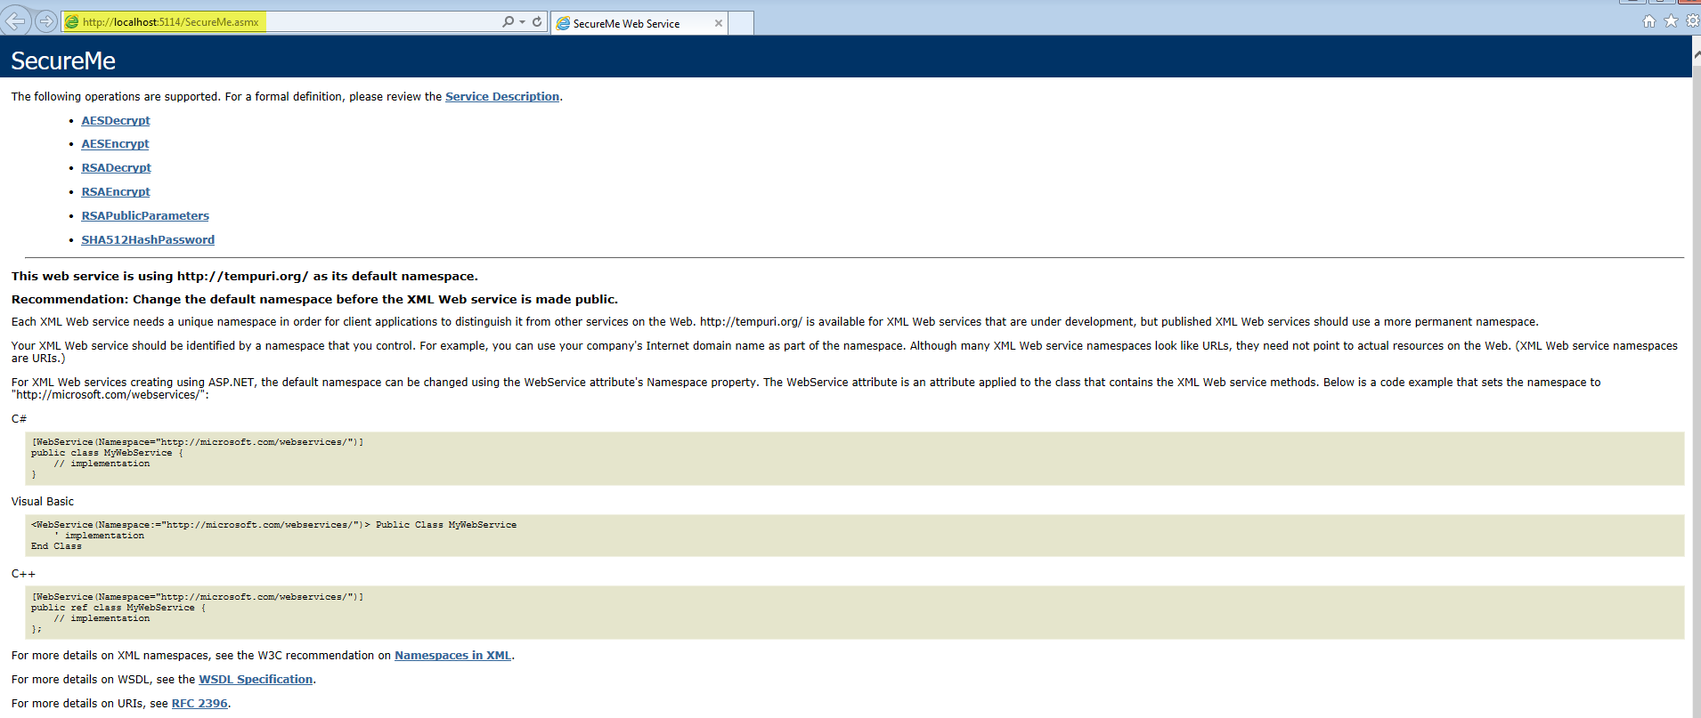

* If web service is listening then clicking on any web method in 4th tab *Message Instructions*, it should open SOAP 1.1/1.2 specification:

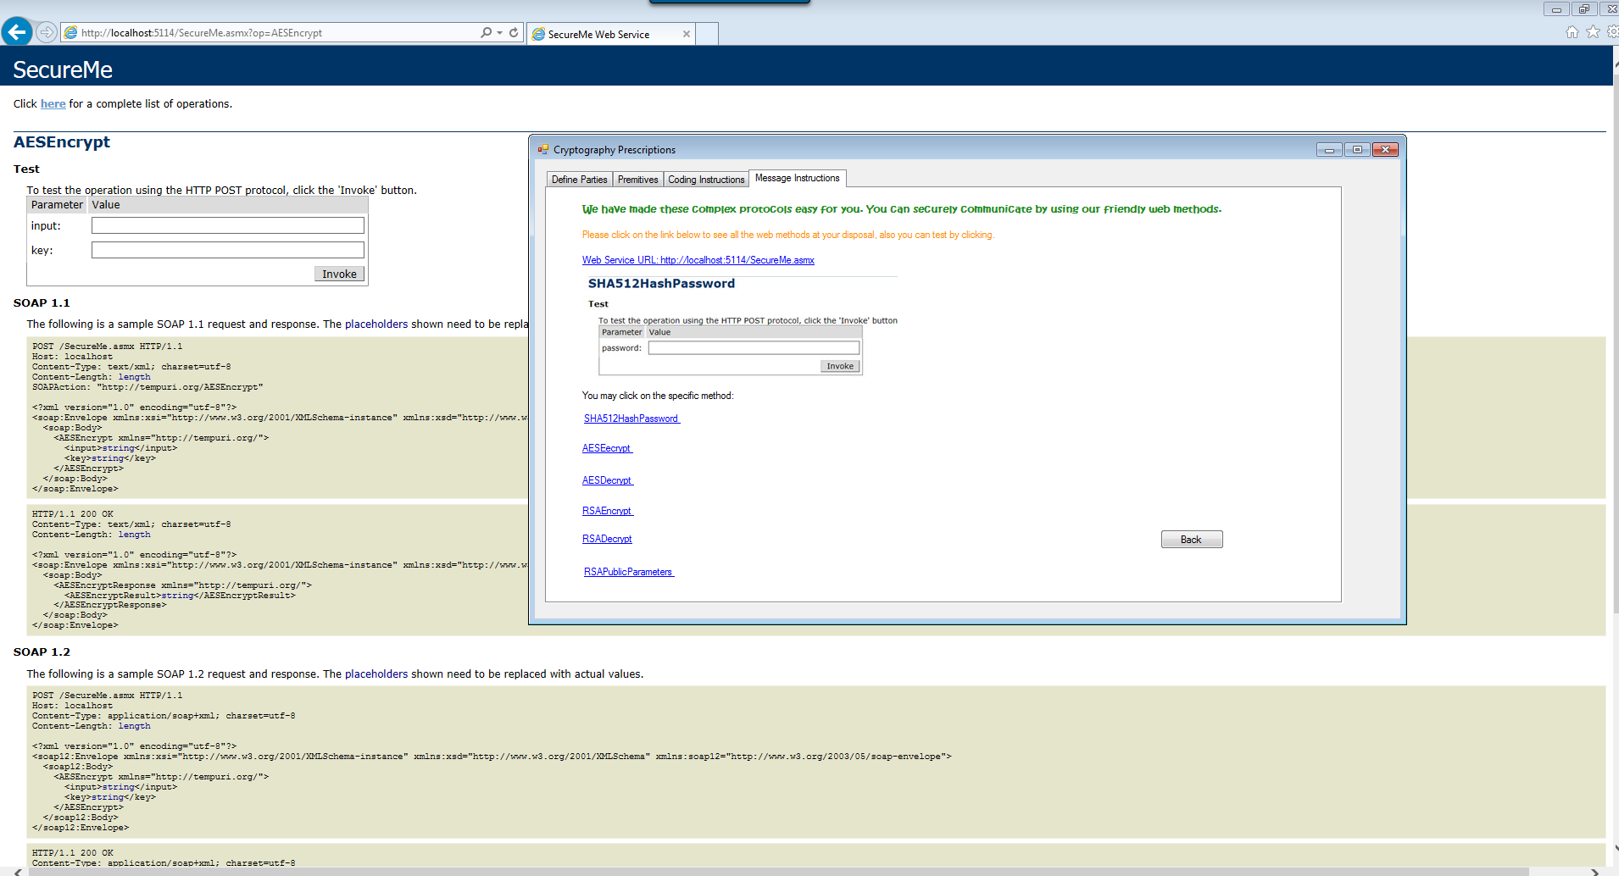

* By providing the input user may invoke any web method of his/her choice:

